If a head/neck injury or possible concussion is witnessed and/or suspected that occurs at any time but may affect participation in any of the Michigan Marching Band activities (e.g. rehearsals, performances, travel) the steps below must be taken to facilitate prompt and safe return to learning and performance. Please note that the steps differ for SMTD students and for non-SMTD students.

SMTD & Non-SMTD Students

Immediate Action
  - Call 911 immediately if any of the following red flag signs or symptoms present after a head impact or neck injury and regardless of whether you believe the injury is life-threatening or not:
    - Loss of consciousness for more than one minute
    - Increasing confusion or inability to stay wake
    - Repetitive vomiting
    - Seizure or convulsion
    - Severe neck pain
    - Weakness, tingling, or burning in arms or legs
    - New persistent double vision or loss of vision
    - Increasingly restless, agitated, or combative
  - Please note that 911 calls are transferred to DPSS. Calling 911 from a university landline directs the call to DPSS. DPSS will determine whether Emergency Medical Services (EMS) needs to be dispatched and/or arrange transportation to the appropriate healthcare professional.
  - Do not attempt to move the student until EMS arrives. Any student with a suspected concussion needs to be serially monitored by a faculty or staff member until DPSS arrives.

Non-SMTD students:

Schedule an Appointment with a Healthcare Professional as soon as possible
  - Schedule an appointment with the University Health & Counseling (UHC), Michigan Medicine, or other qualified healthcare professional within 24 hours of injury.
  - Please note: Only Medical Doctors, Doctors of Osteopathy, Physicians Assistants, and Nurse Practitioners with specific training and experience in concussion assessment and diagnoses employed for that purpose by the university or their place of employment may be consulted for a diagnosis or treatment plan in accord with this Protocol.
  - The recovery process can vary depending on the individual and course demands. Please follow the return-to-classroom and general activity recommendations by the U-M Concussion Center available here (myumi.ch/wwyPG) as well as the Michigan Marching Band Return-to-Performance Protocol available here (myumi.ch/xjemn) for return to Marching Band activities. We recommend that you bring these documents with you to your appointment with a healthcare professional and ask them to review the progressions with you. Based on your diagnosis, they may recommend follow-up appointments and/or make recommendations for where you are in the process. If you have questions regarding returning to practice or performance post-concussion, please contact smtd-wellness@umich.edu.
  - If temporary adjustments are needed to students’ course load, students should contact Services for Students with Disability office (SSD) through their website (ssd.umich.edu) to initiate that process. SSD will need documentation from a healthcare professional regarding your concussion.
  - The final return to performance decision must be made by an appropriate health care professional (e.g. a physician). A Medical Clearance form (available on this page: https://smtd.umich.edu/backstage/wellness/concussion-recovery-support/) must be completed and submitted to the Michigan Marching Band administration (Dr. Richard Frey; rsfrey@umich.edu) for the student to return to MMB activities.

SMTD students

Report the injury within 24 hours
  - Reporting of all suspected or confirmed concussions sustained by SMTD students is mandatory and must be immediate.
  - Report the suspected or confirmed concussion by following this link, or scanning the QR code below. All communication with regards to this injury must be done through the Team Dynamix system to ensure continuity of care and clear communication among the students’ care team, instructors, and administration.

Schedule an Appointment with a Healthcare Professional as soon as possible
  - Dr. Kristen Schuyten will provide assistance with a referral process to University Health & Counseling (UHC), Michigan Medicine, or other qualified healthcare professional within 24 hours of injury, with an appointment scheduled as available for those healthcare professionals.
  - If scheduling an appointment with UHC, please call 734-764-8349 and ask to speak with Anita at reception. If Anita is away, ask for Courtney Campbell. Identify yourself as an SMTD student in need of an urgent appointment and that you need to be evaluated for a concussion. Request an urgent appointment with a sports medicine professional if available, or with primary care if there is a delay.
  - Please note: Only Medical Doctors, Doctors of Osteopathy, Physicians Assistants, and Nurse Practitioners with specific training and experience in concussion assessment and diagnoses employed for that purpose by the university or their place of employment may be consulted for a diagnosis or treatment plan in accord with this Protocol.
  - The student with a diagnosed concussion of any severity level is responsible for scheduling a follow up with Dr. Kristen Schuyten at the on-site Performing Arts Health Clinic for additional concerns and needs within 2 days of injury diagnosis (scheduling link is available here, or scan QR code below). Initial strategies for return-to-learning and -performance will be discussed during this appointment. If the student’s healthcare professional needs to discuss care with Dr. Schuyten, please complete the Family and Friends Outpatient form (available on this page: https://smtd.umich.edu/backstage/wellness/concussion-recovery-support/), or similar form available through your healthcare professional.

Within 3 days post-injury
The following steps need to be completed:
- If, in consultation with a healthcare professional it is determined that an adjustment letter (temporary accommodation) is needed, you need to contact the Services for Students with Disability office (SSD) through their website (ssd.umich.edu) to initiate that process. SSD will need documentation from a healthcare professional regarding your concussion. It is also helpful for SSD to know which stage in the return-to-performance and -learning process you are in, as this information can help guide the process in determining what adjustments you may need. SSD will work with you and your non-SMTD instructors to implement adjustments needed throughout your recovery, and also connect with SMTD regarding their determined adjustments.
- Dr. Schuyten, in collaboration with your instructors, can help you determine adjustment needs. If you have questions about the process of connecting, or have difficulty navigating Accommodate, you can email ssdoffice@umich.edu or call (734) 763-3000.
- Please note that accommodations or adjustments to a course cannot fundamentally alter the objectives of the course. The amount of modification that can reasonably be made to any individual course may vary. Throughout your recovery process, it is important to be aware of what amount of modification can be provided and at what point you may need to work with SMTD to review overall course enrollment and best paths forward for successful degree completion.

Return-to-Learn and Return-to-Performance Strategies
- All diagnosed concussions go through Return-to-Learn AND Return-to-Performance strategies overseen by the administration, and healthcare professional, with faculty and student collaboration and coordination. These progressions are available on the concussion recovery backstage page (https://smtd.umich.edu/backstage/wellness/concussion-recovery-support/).
- Return-to-Learn and Return-to-Performance strategies can and should be completed in parallel when possible, and it may be that a student returns to academic activities before they are cleared for return to performance. The final return to performance decision must be made by an appropriate health care professional and Dr. Kristen Schuyten.
- Return-to-learn and -performance will be initiated after the initial diagnosis by a qualified healthcare professional. Further healthcare appointments and follow-ups will be advised depending on the severity of the concussion and post-concussive symptoms.

Within 1 Week Post-Triage Appointment
- Students should schedule an additional follow-up appointment through the Performing Arts Health Clinic with Dr. Kristen Schuyten within 1 week after the initial triage appointment for further progressions and testing (when necessary) to assist with additional decision making. During this appointment, if a student is still displaying concussion symptoms that are limiting their participation in class, a comprehensive plan for Return-to-Learn and -Performance may be created. With student consent, Dr. Schuyten will provide communication with the students’ instructors for current limitations and/or stage of concussion protocol and modifications needed for the student (including specific movement, audio, visual, and/or postural limitations when returning to learn and performance).
- Concussions need to be managed on a case-by-case basis, as every concussion will present differently depending on the student. In order to address each student’s specific needs, we strongly encourage instructors to collaborate with Dr. Kristen Schuyten and students to develop and implement course-specific academic supports to reduce their symptom burden during class. With the growing technology use in higher education, it is important to consider how stimuli from technology (e.g., noise, blue light, etc.) may increase students’ symptoms when modifying course assignments. Thus, we developed a general list of recommendations for instructors and students to consider based on their symptom presentation:
  - Headache or sensitivity to light: Modify course assignments to reduce technology-use/screen time (e.g., oral presentation or examination, peer note taker, allowing sunglasses/hats to reduce light, print-out copy of notes/assignments/exams)
  - Sensitivity to noise: Modify course assignments to reduce noise stimuli (e.g., audio recordings of lectures, wear noise-canceling headphones or earplugs during loud courses/performances, complete exams in a distraction-free environment, etc.)
  - Dizziness or Difficulty Balancing: Perform any exercises prescribed by a healthcare professional (e.g., physician, physical therapist, athletic trainer, etc.) during movement-based classes.
A concussion recovery kit containing blue-light blocking glasses, sunglasses, and other supplies is available to you either directly from Dr. Schuyten or the Wellness Office (2219 Moore building).
- The final return to performance decision must be made both by an appropriate health care professional (e.g. a physician) and Dr. Kristen Schuyten. Please make an appointment with Dr. Schuyten through the Performing Arts Health Clinic and an urgent appointment with a physician through UHC. Call Anita at 734-764-8349 and request an appointment for medical clearance after a concussion. A Medical Clearance form (available on this page: https://smtd.umich.edu/backstage/wellness/concussion-recovery-support/) must be completed and submitted through Team Dynamix for the student to return to class and performance.

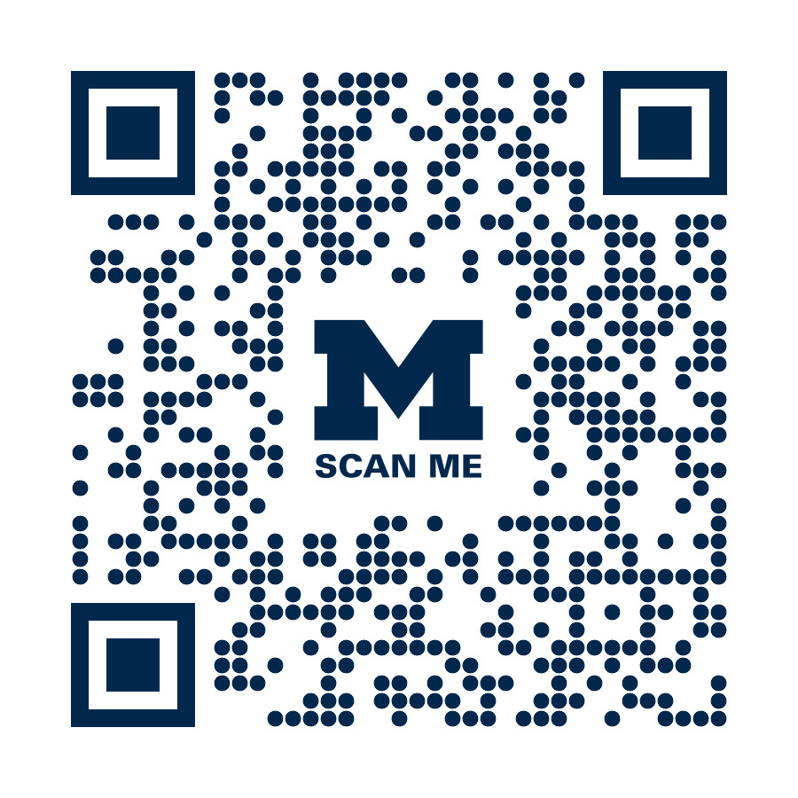
Scan this QR code to access for all pertinent forms and resources
relative to this protocol:

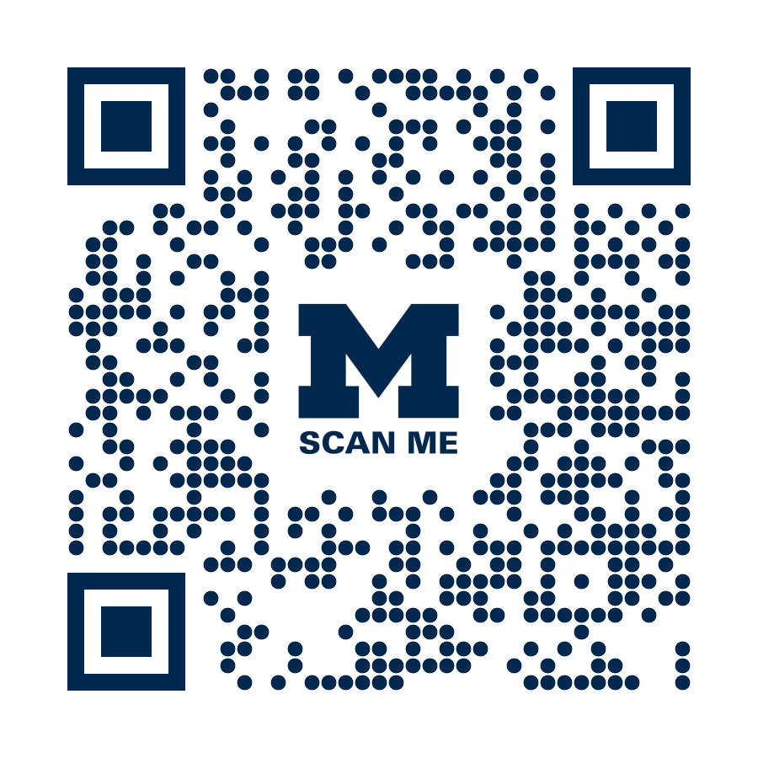

Scan the QR code to report an acute, head/neck, or
chronic injury (SMTD students only):

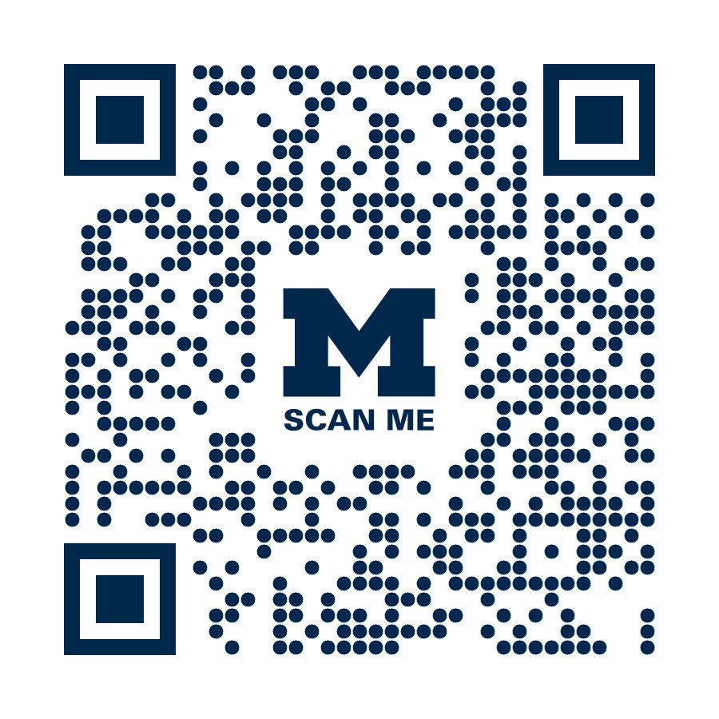

Scan the QR code to schedule
an appointment through the SMTD Performing
Arts Health Clinic (SMTD students only):

