Friends of Dance Donation Form goes here
This is available in the Resources section of the department website

Add upcoming events if you can!

Department of Dance Selected Upcoming Events:
Dec. 1-2 | Dance & Related Arts Performance
Dec. 7 | Composition Class Showing
Dec. 7-9 | BFA Concert #1
Dec. 10 | Congolese Class Showing
Dec. 10 | Improvisation Class Showing
Feb. 1-4 | Power Center Concert

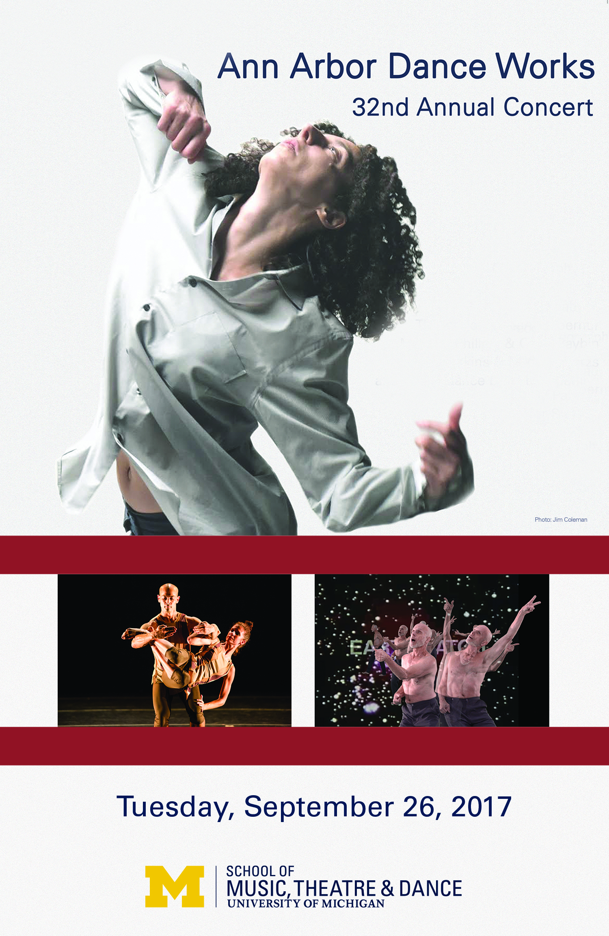
Ann Arbor Dance Works
32nd Annual Season

Betty Pease Studio Theater

University of Michigan Dance Building

Lighting Designer and Stage Manager: Mary Cole

You Would

Choreography and Performance: Sean Hoskins & Molly Paberzs

Music: Eric Andrew Kuhn; Text by Sean Hoskins, spoken by Sean Hoskins & Molly Paberzs

Video Projections: Sean Hoskins & Molly Paberzs

Valet/Vanity

Choreography and Performance: Colin Mysliwiec Raybin &
Michael Spencer Phillips

Music: Preludes: Op. 11 N. 8, 4, 10, 6, 15 by Alexander Scriabin

Music Performance: Shalva Vashakashvili

Be Well

Choreography: Tzveta Kassabova
Music: Arvo Part
Costume: Tzveta Kassabova
Performance: Joshua Bisset & Tzveta Kassabova

ACKNOWLEDGEMENTS

Many people as always have come together to make these performances possible, and their work is truly appreciated. A very special thanks to the choreographers, dancers, and musicians for their committed artistry and generous work, and to Mary Cole for her exquisite lighting design and technical expertise; to Sean Hoskins for his valuable production and technical assistance, as well as his terrific graphic design; to all the hardworking crew members; to Jillian Hopper for her expert rehearsal coaching of the Gillen work; to Katie Gunning for her meticulous financial oversight and generous administrative support; to Theresa Hartman of University Productions for the loan of costume pieces; to Christian Matijas Mecca and Randall Bibri for assistance with piano tuning; to Rochelle Clark of MUTO for her ticketing assistance; to Kirk Donaldson for his phenomenal photography. A special thanks to our audience members for bringing our works full circle.

FUNDING

Generous funding and sponsorship for these performances was received from the Department of Dance, the School of Music, Theatre & Dance, and the Gay Delanghe Endowment.

PRODUCTION CREW

Technical Director: Sean Hoskins

House Manager: Katrina Granger

Assistant Stage Manager: Cailin Ferguson

Light board operator: Mary Cole

Sound board operator: Selena Moeljadi

Stage crew: Michaela Esteban

Graphic Designer: Sean Hoskins

Molly Paberzs is an independent dancer, choreographer, improviser and educator originally from Ann Arbor, MI. Molly received her BFA in Modern Dance Performance and emphasis in Choreography from the University of the Arts in Philadelphia, PA and her MFA in Dance from the University of Michigan. Molly performed with several independent artists as well as Group Motion Dance Company in Philadelphia while presenting her work at festivals and through artist grants along the East Coast. She is currently continuing her creative research in improvisation and compositional structures. Molly is a part-time lecturer at Eastern Michigan University, on staff at the University of Michigan’s School of Kinesiology, and a curatorial assistant for Professor Clare Croft’s continued work on EXPLODE Queer Dance.

Peter Sparling is the Rudolf Arnheim Distinguished University Professor of Dance and Arthur F. Thurnau Professor of Dance at University of Michigan. A graduate of Interlochen Arts Academy and The Juilliard School, Sparling was a member of the José Limón Dance Company and principal dancer with Martha Graham Dance Company. He has performed and staged Graham's works all over the world and on PBS's Dance in America. He has had extensive experience as artistic director, (Peter Sparling Dance Company/Dance Gallery Foundation), choreographer, performer, teacher (U-M Distinguished Faculty Award, Governor's Michigan Artist Award), lecturer, video artist, writer (Ballet Review), collaborator, administrator (former chair, U-M Dance Department) and dance/arts consultant. His videodance Babel was selected for the 2007 New York Dance on Camera Festival, the 2008 American Dance Festival Dance Film & Video Festival and has toured the world. His made-for-TV work, Climbing Sainte-Victoire, was broadcast on Michigan Television in April 2009, and his screen dance, The Snowy Owl, was featured at the Short Film Corner of the 2015 Cannes Film Festival.

Ali Woerner is Associate Professor of Dance at Oakland University. She received her MFA from the University of Michigan and her Bachelor of Performing Arts from Oklahoma City University. Throughout her diverse career within both commercial (performing as a Radio City Rockette for six years) and contemporary mediums, Ali has performed and taught all over the world, including Colombia, Costa Rica, Berlin and Korea. In 2013, Ali joined forces with Thayer Jonutz to co-found the professional contemporary modern dance company, Take Root, currently in residence at OU. Ali has choreographed for Inaside Jazz Dance Chicago, Patterson Rhythm Pace Dance Company, Wayne State University, Albion College, Oakland University’s Repertory Dance Company, Oakland Dance Theatre and Eastern Michigan University. She serves on the Review Board for the Journal of Dance Education where her articles and book reviews have been published. Ali is the Program Director for Take Root’s Dance for Parkinson’s Disease Outreach, now in three locations.

Clonal Renderings 2: Canon in 2x3

Video and Performance: Peter Sparling
Music: China Gates by John Adams, performed and recorded by Edith Lin

Special Thanks:
U-M Duderstadt Center Digital Media Commons
Jacques Mersereau, Director of Photography
Jeff Alder, Lighting Design
Dave Greenspan, Audio Recording Engineer

Note: Composed for the screen as a 3-part canon, Clonal Renderings 2 weaves replicas of the same dancer (Sparling) negotiating a landscape of found footage. Propelled by John Adams's driving score performed by Edith Lin, the three identical duets complete their cycles 8 seconds apart, moving back into infinite depth and forward, eventually climbing out of the frame.

Ink (excerpt)

Choreography and Performance: Thayer Jonutz & Ali Woerner

Score: Multi-media created by Jon Anderson, “Ink” text read by

Kathleen Pfeiffer

Music Performance: Jon Anderson (Multi-media/Piano), Danny DeRose (Viola)

Costumes: Christa Koerner

Note: Based on the short story “Ink” written by Kathleen Pfeiffer. Ink premiered by Take Root at Uferstudios in Berlin, Germany May 2015.

Lines

Choreography: Shannon Gillen and company

Music: Martin Durov
Rehearsal Director: Jillian Hopper
Dancers: Sophie Allen, Sally Butin, Michaela Esteban, Al Evangelista, Cailin Ferguson, Alyssa Gorman, Maddy Joss, Emma Lambert,
Johnny Matthews III, Hannah Marcus, Katherine Mousel, Grace Nagelvoort, Annelise Senkowski, Katie Soloway, Florence Woo
Understudies: Victoria Briones, Shea Carponter-Broderick

Biographies

Jon Anderson’s music has been described as “haunting,” mixing “electronic beats” with a “cocky mélange of aggression and tongue-in-cheek humor.” He writes a variety of music for traditional acoustic ensembles such as orchestra, band, and chamber groups, as well as less traditional ensembles involving interactive computer music, which frequently incorporates physical movement and dance as structural elements. Having won awards from institutions such as the Academy of Television Arts & Sciences, the Society of Composers Inc. & ASCAP, and the Pierre Schaefer International Competition of Computer Music, his works have been commissioned and performed by orchestras, ensembles, and soloists throughout the world. In addition to being Take Root's resident composer, Anderson teaches music theory and composition at Wayne State University in Detroit.

Mary Cole is the lighting designer, stage manager, and technical director for the Department of Dance and Ann Arbor Dance Works. She has worked extensively as lighting designer throughout Southeast Michigan, in such places as Performance Network, Lansing Community College, The Jewish Ensemble Theatre, and Plowshares Theatre Company. A founding member of Ann Arbor Dance Works, she joined the UM Dance faculty in 1985 after receiving her BS in Dramatic Arts at EMU and doing master’s work at U-M.

Jillian Hopper specializes in the work of Doris Humphrey as a trustee of The Doris Humphrey Foundation, UK. In addition to teaching at the University of Michigan, Hopper has taught Humphrey technique at Hillsdale College, Middlesex University (London, UK), The Place (London, UK) and Northern School of Contemporary Dance (Leeds, UK.) Jillian received her MFA in Dance from U-M where she performed in works by Sidra Bell, Monica Bill Barnes, Amy Chavasse, Bill DeYoung, Jessica Fogel, and Peter Sparling. She trained at Gus Giordano Jazz Dance Chicago, and Joel Hall Jazz Dance Chicago, later studying at Middlesex University, London UK where she gained a BA Hons in Dance Choreography. Her professional dance credits include Intimate Contenders and HR-Artworks London UK, in which she was a featured soloist. This is her fourth season with Ann Arbor Dance Works.

Sean Hoskins investigates the intersections of dance and technology as a choreographer, performer, teacher, and screendance creator. Originally from VT, he studied dance at Middlebury College and has an MFA in dance from the University of Michigan. Sean has presented choreographic work and taught classes and workshops in various locations and schools throughout the country and at the National College Dance Festival. He danced with Leslie Seiters, Peck Peck Dance, and ChavasseDance&Performance, as well as in works by Terry Creach, Jessica Fogel, Paul Matteson, Peter Schmitz, Helanius Wilkins, and many other collaborators. Sean is currently the Dance Technology Coordinator and Production Assistant, as well as part-time faculty at University of Michigan.

Prior to founding Take Root Dance Company, Thayer Jonutz danced with Repertory Dance Theatre where he performed both classic and contemporary works by Douglass Dunn, Zvi Gotheiner, Daniel Nagrin, Bill Evans, Scott Rink, and Susan Hadley. Thayer earned his MFA in Dance from the University of Michigan, performing in the Peter Sparling Dance Company. Currently, Thayer is an Associate Professor of Dance at Oakland University where he directs the Repertory Dance Company and teaches modern, improvisation, and dance pedagogy. In addition to performing with Take Root, Thayer has performed with Patterson Rhythm Pace Dance Company, Rustic Groove, Agua Dulce Dance Theater, Eisenhower Dance, and Rebudal Dance, among others. Thayer is the program director for Take Root’s Arts Education Outreach.

Tzveta Kassabova is a Bulgarian born choreographer, costume designer, and installation artist, named one of the "25 to watch" in 2012 by Dance Magazine.
At different times she has been a gymnast, physicist, and meteorologist. As a dancer, Kassabova has been part of Ed Tyler, Sara Pearson/Patrik Widrig and David Dorfman Dance companies, and has performed in works of Mark Haim, Nancy Bannon, Maurice Fraga, Zoltan Nagy, Joshua Bisset, Netta Yerushalmy, Bill Young and Colleen Thomas, among others. Her choreography has been presented nationally and internationally. She joined the UM faculty in 2016 in the Department of Theatre and Drama, and also is teaching this semester in the Department of Dance.

